Magnolia PUD
Draft Perry Hall Improvement Association Response
Revised June 10, 2020

Introduction – On March 31, 2020 the law firm of Smith, Gildea & Schmidt submitted an application to the Baltimore County Council for a 62 townhouse project known as Magnolia.
The Magnolia PUD is located directly across the street from Joppa View Elementary School on Honeygo Boulevard within the Perry Hall community.

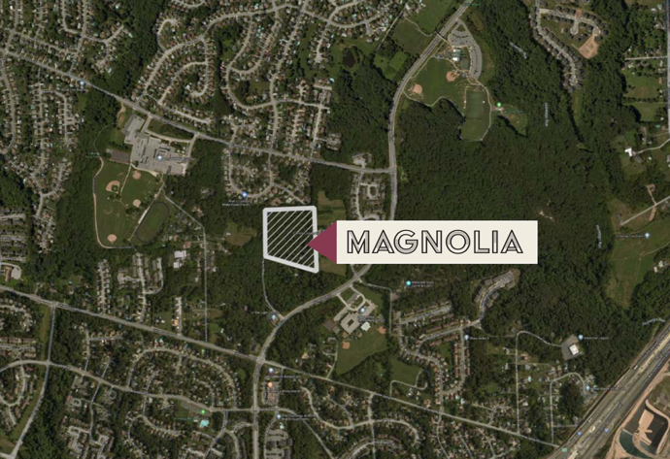

The Magnolia PUD is located on approximately 10 acres. The development proposal is to construct 62 townhomes.

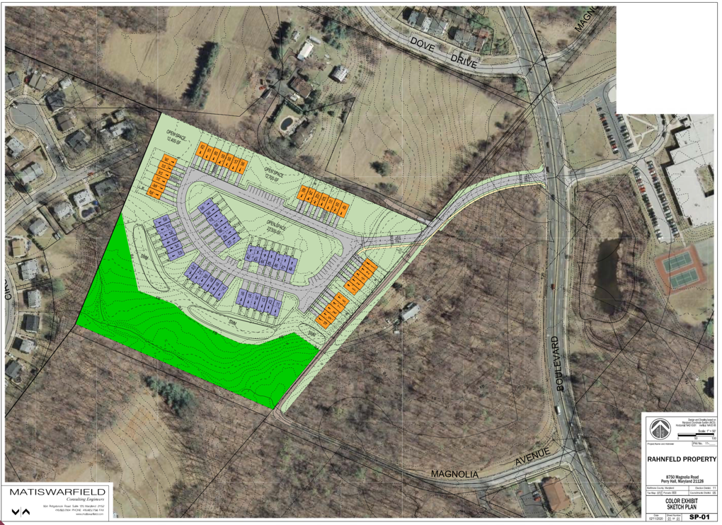

The zoning on the property is DR 1 which at 10 acres would allow for 10 single-family detached homes by right. Access to the development would intersect with the lower (main) entrance to Joppa View Elementary School. The development would require a Planned Unit Development approval because it exceeds the zoning on the property.

The Perry Hall Improvement Association Board (PHIA) has undertaken a preliminary review of the proposal and provides the following comments.

Summary – At this point in time, it is the opinion of the PHIA that it would be fiscally irresponsible to support anything other than what the current zoning (DR 1 @ 10 acres = 10 dwelling units) would allow by right on the PUD Magnolia project. This Magnolia PUD should NOT be allowed to proceed at any density other than what is permitted by right.

The Perry Hall Improvement Association decision not to support the Magnolia PUD is based upon the existing school overcrowding and community factors.

- Existing School Overcrowding – As more fully described within this document, all of the elementary schools within the cluster area are between 101.57% to 120.5% capacity.
All but one elementary school has between 1 to 8 relocatable temporary classrooms on site. The average number of relocatable classrooms per school is 4.5.

Perry Hall Middle School is currently at 117.06% capacity with 232 students over the State Rated Capacity.

No development should be approved until the school overcrowding issues are addressed (being addressed to mean schools are funded and under construction).

- COVID19 – The effect that COVID19 will have on schools cannot be ignored. And at this point in time and until a vaccine is available, all schools could potentially have severely reduced student capacities. The Baltimore County Public Schools does not as of yet have a firm plan for school reopening. Solutions that have been discussed (Baltimore Sun, 5/27/2020, Liz Bowie) include - spacing desks, alternating schedules etc. Clearly, if schools can not handle existing capacities how will they be able to handle capacities at ½ or 1/3 reduced class sizes.

No development should even be considered until the full impact of school reopening is made available and fully implemented so a comprehensive assessment can be addressed on the reopening of schools. In fact, the PHIA would support a temporary school moratorium until this can be addressed.

- Zoning – The surrounding community area is now largely developed. Between 1971 and 1996 when the area was designated as a Growth Area, the zoning for this site at that time was DR 5.5. Between 2000 and 2008 when the area was still designated as a growth area but the zoning for the site was changed to DR 3.5. Since 2012 and up to today, 2020 the site has been zoned DR 1 when the area was changed to a Community Conservation Area. All of the existing townhouse developments in the area were developed at DR 5.5 or DR 3.5 density (or in most cases developed at less density). The proposed Magnolia PUD is proposed at DR 6.2 density.

- Baltimore County Master Plan 2020 - The County designation of the PUD area is Community Conservation (pages 39 – 62, Baltimore County Master Plan 2020). Key policies include supporting existing communities with adequate infrastructure (schools, roads, parks, water, sewer, police, fire etc.). Clearly, the proposed Magnolia PUD is not in keeping with these policies.

- Fiscal Impacts – Fiscal impacts need to be evaluated on two levels. First, if the development were allowed to proceed, the taxes paid by the development would not even support the amounts necessary for schools (schools currently are 51% of the County budget) and not to mention police, fire, trash, open space and other services that the County provides. This assessment is based upon the average taxes per townhouse versus the average cost to educate a Baltimore County student.

Second, with the impact of COVID19 on the County budget, money for new school construction and operation (teachers, supplies, transportation, state of good repair etc.) will not be available for many years into the future. Until the County budget is fully reconciled, no residential development should be approved.

- County Growth – The Perry Hall area over the next 25 years is not expected to increase in population or households in any significant manner. During that same period, the population is expected to grow by 1,112 people/503 households. Given the existing developments currently approved or under construction the Perry Hall area is already going to meet its fair share of County growth and development. In view of the aforementioned discussion the PHIA is going on record to oppose the development of Magnolia as excessive (62 PUD units versus 10 allowable units), and not warranted.

Detailed Analysis

School Capacity – The elementary schools within the Perry Hall area are all currently at capacity or exceeding same. The Adequate Public Facilities Law allows development to use any spare capacity in an adjoining school to accommodate students, however the existing elementary schools are all at or over capacity. No residential development should be approved until the schools are fully funded in future capital budgets.

The Perry Hall Middle School is now at 117.06% capacity (232 students over capacity). Even using the state average of 22 students per class room (which does not include smaller class sizes for special education, art etc.) translates into 10 extra classrooms will be needed for this school.

Based upon the County assessment of pupil yield, the Magnolia townhouse development is expected to yield 23 elementary students (roughly one classroom), 9 middle school students,
and 9 high school students.

COVID19 – The COVID19 pandemic has placed a great deal of uncertainty on how schools will operate and function in the future. In a non-vaccine environment if students are in schools they will have to practice proper safety protocol and procedures. Keeping students separated and safe from infection will necessitate in reduced class sizes and staggering days of attendance with possible year-round attendance. Lunch rooms, art rooms, bathrooms etc. will all have to be restructured. Clearly, if the existing schools are unable to accommodate students/schools that are current over capacity, in a non-COVID19 environment then reduced capacities at 30% - 50% will not be able to be accommodated. Within the current environment approving density for the Magnolia PUD at over 6 times the allowable density would not be responsible.

Zoning – The zoning history of the proposed development is provided per the chart below.

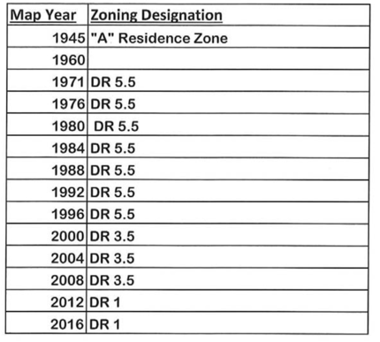

The surrounding community area is now largely developed. Between 1971 and 1996 when the area was designated as a Growth Area, the zoning for this site was DR 5.5. Between 2000 and 2008 when the area was still designated as a growth area the zoning for the site was changed to DR 3.5. Since 2012 up to today 2020 the site has been zoned DR 1 when the area was changed to a Community Conservation Area. All of the existing townhouse developments in the area were developed at DR 5.5 or DR 3.5 density. The proposed Magnolia PUD is proposed at DR 6.2 density. The zoning on the Magnolia PUD site has been consistently adjusted over time to accommodate the planning for the County and community. During years of growth and development the zoning was DR 5.5 (which is still below the DR 6.2 the developer is requesting) and during the period of community conservation the zoning was reduced to DR 3.5 and DR 1.

This zoning was not put in place to allow negotiation for higher density yet rather to ‘properly
zone’ the area.

Baltimore County Master Plan 2020 and Community Plans - The designation of the PUD area in the Baltimore County Master Plan is Community Conservation (pages 39 – 62, Baltimore County Master Plan 2020). Key policies include supporting existing communities with adequate infrastructure (schools, roads, parks, water, sewer, police, fire etc.).

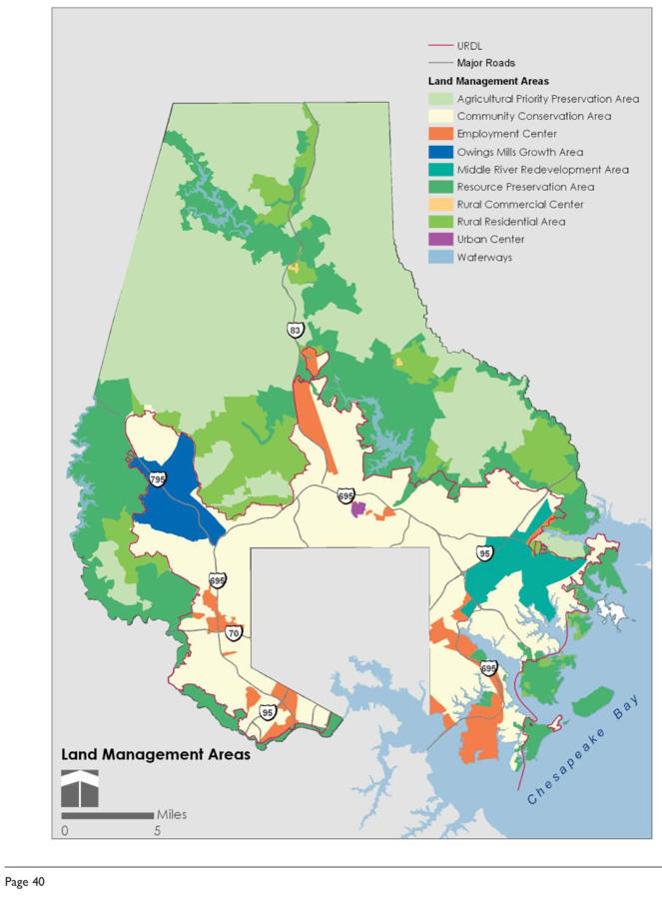

The Magnolia PUD development is located within a T-3 transect zone. The zone allows detached single-family homes. The plan states the following.
“T-3 (Sub-Urban Zone) includes low-density residential areas, adjacent to higher zones that contain mixed use. Home occupations and outbuildings may be allowed. Landscaping is naturalistic and setbacks are relatively deep. Blocks may be large and the roads irregular to accommodate natural conditions.” Baltimore County Master Plan, page 29.
“The CCAs were first delineated in the 1989-2000 Master Plan. By adopting these areas as a new land use designation, the County set precedent, and began a much-needed push to “conserve, revitalize and enhance our older residential communities.” The move to protect and invest in the older communities, and revitalize their commercial hubs followed the previous period when most public investment went to the new designated Growth Areas.” Baltimore County Master Plan 2020, page 39.
The Perry Hall Community Plan, adopted February 22, 2011 provides the following.
“Although the Perry Hall Community Plan incorporates many suggestions, five overall themes are critical. First, this plan acknowledges that the period of large-scale development in Perry Hall is over.” page 1.
“Base future zoning decisions on consistent policies that reinforce Perry Hall’s character and neighborhood appeal.” page 4.
Clearly, the proposed Magnolia PUD is not in keeping with these policies.

Fiscal Impacts – As previously mentioned the Magnolia PUD proposes 62 owner occupied townhomes and is expected to generate 23 elementary students (roughly one more classroom), 9 middle school students, and 9 high school students. The average annual cost to educate a student in the Baltimore County School system is $14,864 ($1.71 billion dollar budget FY20, 115,038 students).

Using the townhouse development located closest to the Magnolia PUD site, the average annual taxes paid by one of those townhomes is approximately $3,300.00. Based upon this average one could expect to generate annually approximately $204,600 in real property taxes from the Magnolia PUD development. The total annual cost of educating students from the development would be approximately $609,424 (41 students X $14,864 = $609,424). This does not include other public services such as roads, parks, police, fire, trash pick-up, libraries etc.
The Magnolia PUD townhomes will need to rely upon additional growth and development from the business sectors of the County in order to be financially viable. It will be several more years before the current business economy returns to normal and starts to expand.

County and Perry Hall Projected Growth - The population and household growth in the Perry Hall area is not expected to increase in any significant manner. In the next 25 years the population is expected to grow by 1,112 people/503 households. Given the existing developments currently approved or under construction (Strawbridge, Honeygo Run, Meadows at Honeygo, Gerst Farm, Perry Hall Station), Perry Hall is already going to meet it’s fair share of growth and development for this foreseeable future. The PUD dwelling unit increase from 10 houses to 62 townhouses is excessive, unwarranted and not justifiable.

The charts provided below show the growth and development predicted for the Perry Hall Area.

Population | 2015 | 2020 | 2025 | 2030 | 2035 | 2040 | 2045
Perry Hall | 29,742 | 30,136 | 30,089 | 30,175 | 30,513 | 30,910 | 31,248
County | 828,445 | 849,846 | 858,083 | 866,117 | 878,444 | 892,653 | 903,503
Household | 2015 | 2020 | 2025 | 2030 | 2035 | 2040 | 2045
Perry Hall | 11,846 | 11,868 | 11,906 | 11,943 | 12,078 | 12,237 | 12,371
County | 322,738 | 328,174 | 332,906 | 336,349 | 341,413 | 346,943 | 351,163

